

Mehran University of Engineering and Technology Jamshoro

**ASSIGNMENT : LAB 03**

**SUBJECT : PROGRAMMING FUNDAMENTALS**

**ROLL NO : 24BSAI29**

**SUBMITTED BY : SYED MUHAMMAD QASIM**

**SUBMITTED TO : MA’AM FAHAMA BARKZAI**

|  |
| --- |
| Department of Software Engineering  Mehran University of Engineering and Technology, Jamshoro |

|  |  |  |  |
| --- | --- | --- | --- |
| Course: AI-112– Programming Fundamentals | | | |
| Instructor | Engr. Fahama Barakzai | **Practical/Lab No.** | 03 |
| Date |  | **CLOs** | 3 |
| Signature |  | **Assessment Score** | 01 Mark |

|  |  |
| --- | --- |
| Topic | Working with various operators, Operator precedence |
| Objectives | * To become familiar with operators in C++. * To study about the categories of operators. * Increment and Decrement operators. * Operator precedence and Associativity. * Rational, Logical and Bitwise operators. * Type casting. |

|  |
| --- |
| Lab Discussion: Theoretical concepts and Procedural steps |

**TOOLS: TURBOO C++/ DEV C++/ VS-CODE/ CODE BLOCKS**

|  |
| --- |
| Lab Tasks |

1. Try to create a C++ program that declares 5 floating numbers and print their total sum and average.

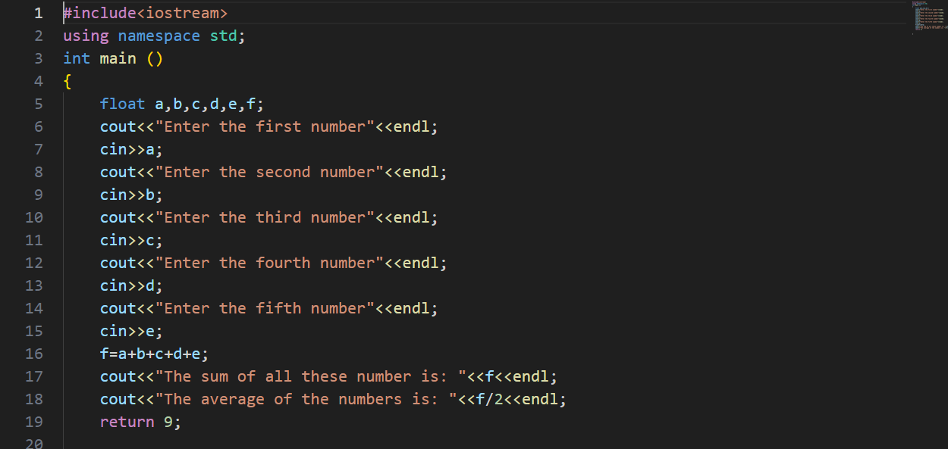

**Expected Result:**

The output of the program is:

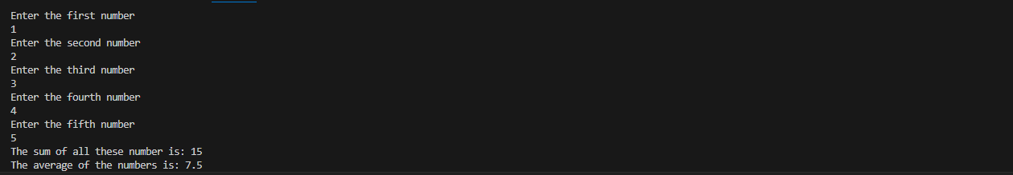

1. Try to create a C++ code that takes radius for a circle at runtime and print the circumference, diameter and area for the circle.

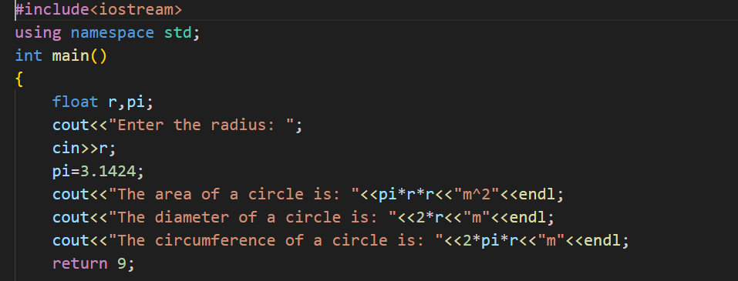

**Expected Result:**

The output of the program is:

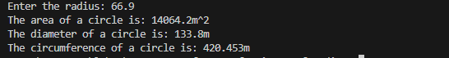

1. Practice a C++ program that takes a floating-point number as an input and separates the integral part and stores it in an integer variable and fractional part and stores it in a floating-point variable.

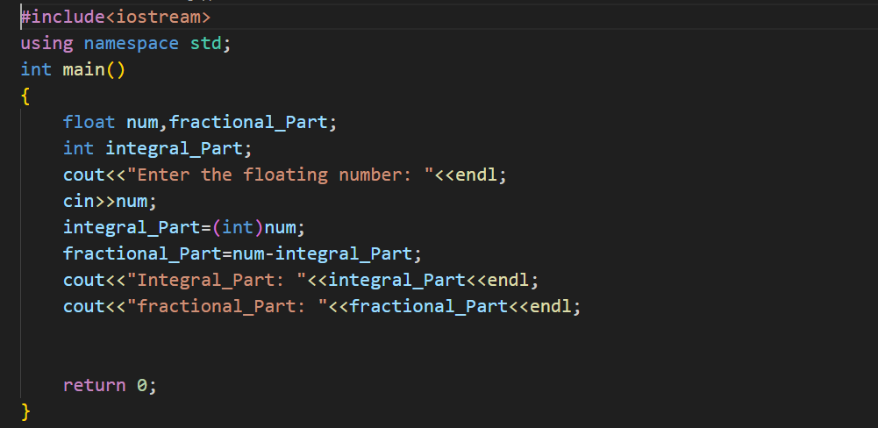

**Expected Result:**

The output of the program is:

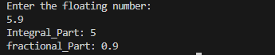

1. Rebuild a C++ program to concatenate two strings using string data type.

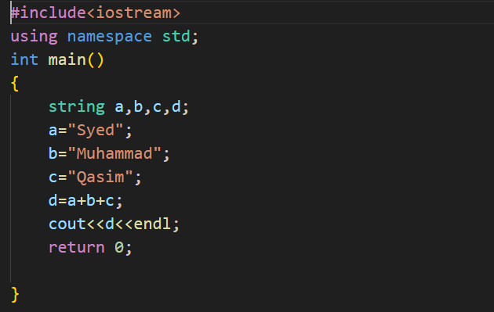

**Expected Result:**

The output of the program is:



1. Practice a C++ program that takes temperature in Fahrenheit in input and converts to Celsius.

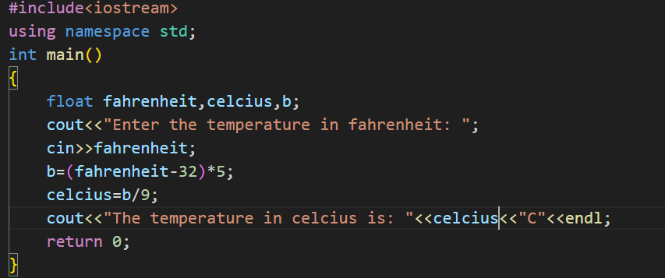

**Expected Result:**

The output of the program is:



*************************************************************************************